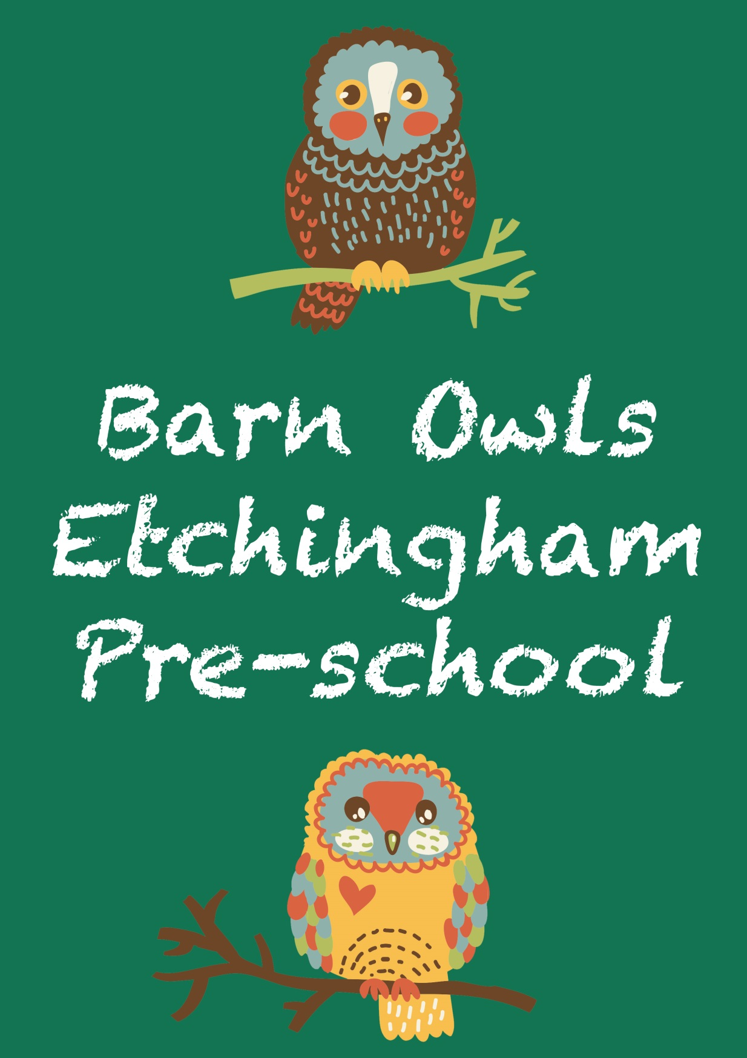

**WELCOME INFORMATION**

**Our Staff**

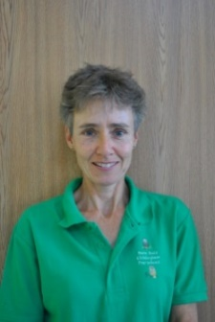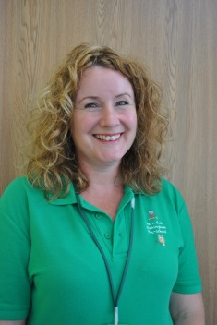

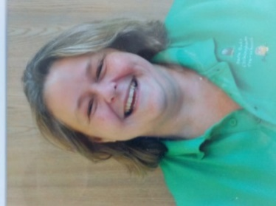

Jo Helen Nicky Deputy Manager Manager Safeguarding Officer

SENCO/Key Person Key Person

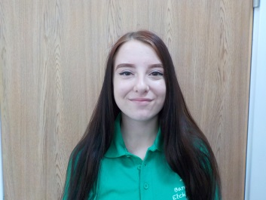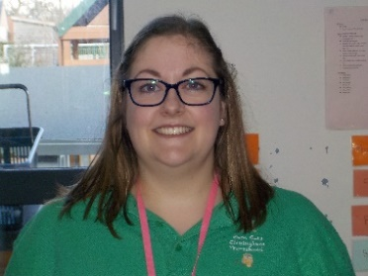

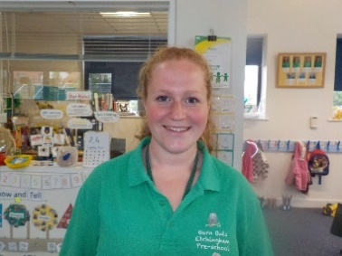

Ellie Tasha Chloe

Key Person Key Person Key Person

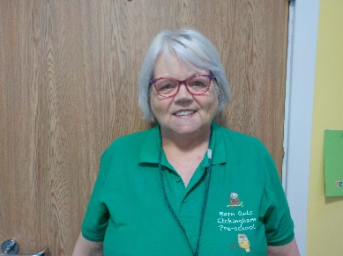

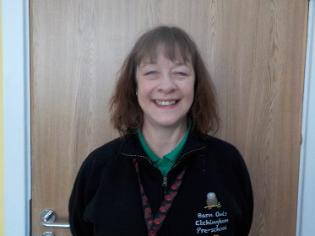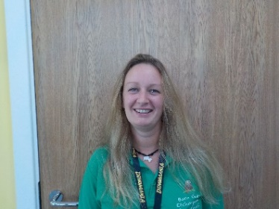

Hayley Liz Angela

Pre-School Assistant Pre-School Assistant Pre-School Assistant

(on maternity leave)

**What Your Child Will Need**

Please could children bring with them to pre-school a pair of named wellies and a waterproof coat/all in one as they have the opportunity to go outside in all weathers and a sunhat and suncream if the weather is hot. We ask that you apply suncream to your child before pre-school and then give named suncream to a member of staff to be re-applied after lunch. Please ensure that your child has footwear that is suitable for running around outside (not flipflops please). **All children will go outside every day unless unsafe for them to do so!** Children will also need a change of clothing in case of accidents, although we do have limited spare clothing if necessary.

Children are welcome to bring a special toy or comforter to pre-school. However, we would prefer that this is kept in their bag or the Treasure Box if possible to reduce the risk of misplacing a much loved toy! We encourage the children’s independence as much as possible and simple fastenings on clothing, shoes and coats helps children to achieve this. Children have the opportunity to engage in lots of messy play and we would also ask that they don’t come to pre-school in clothing that wouldn’t be improved by the addition of mud, paint, glue or water!

**Hygiene**

Staff support children to ensure they regularly and effectively wash their hands, rubbing in soap for 20 seconds before washing it off. Children will be asked to wash their hands regularly throughout the day, including before eating, after using the toilet, and after sneezing or blowing their nose, as well as if they are dirty. Staff also promote the “catch it, kill it, bin it” message and children are encouraged to either sneeze/cough into a tissue or into the inside of their elbow. Your help in teaching children how to blow and wipe their own noses is much appreciated!

Resources used are cleaned regularly, and so too are high traffic areas such as door handles, taps etc.

**On Arrival**

The playgroup day begins at 9.00am (or 8.45am by prior arrangement. The early start will be charged at ¼ of the hourly rate).

When your child first joins the setting, parents are encouraged to come in with their child and make sure they are settled before leaving them. Once children are familiar with the setting, the pandemic has shown us that children settle much faster and with less upset if parents are able to say goodbye at the door and not come into the setting. Staff will help children to hang their coat and bag on their named peg, put lunchboxes on the lunchbox stand and then to find their gingerbread man and add him to the pre-school path. We encourage parents to come into the setting if there is something they need to discuss with their child’s key person but if it is possible to wait until the end of the day that would be helpful. General messages can be given to the staff member on the door or if you would like to discuss anything by telephone, please let us know and we will arrange a time to call.

Once the majority of children have arrived, the main door will be closed. If you are arriving outside of our normal hours, please knock on the door and wait for a member of staff to let your child in.

**Snack Time**

The group usually operates a rolling snack time which means that children can visit the snack table for a drink and something to eat at any time during the hour it is open. When children first join the setting they often choose not to come to snack as they are too busy exploring! We normally ask parents to donate an item for snack bar each week which can be placed into the ‘bowl’ outside the setting. This could be fresh fruit, bread, crumpets, yoghurts, breadsticks, cucumber or carrots, anything healthy in fact. Snack donations must be in original packaging (unless fresh fruit and vegetables!) and all fruit and vegetables will be washed before use. To protect the children’s dental health, we don’t give them dried fruit for snack and we ask that you check to ensure products aren’t too high in salt or sugar (the traffic light system is good for this). Fresh water is available at all times and we also have milk at snack times. Parents do occasionally bring in cake, biscuits or sweets to celebrate their child’s birthday and these will be outside the setting at the end of the day for you to decide whether or not you would like your child to take one home. Barn Owls operates a STRICT NO NUTS POLICY.

**Lunchtime**

Children have lunch between 12.00 and 12.30pm in the school hall and have the opportunity to eat a school dinner at a cost of £2.85 for main course and dessert. Members of staff sit with the children and it is a very social occasion, consequently children don’t always have time to finish everything in their lunchbox! Children are strongly encouraged to eat the savoury items before moving on to the sweeter foods and we ask that children do not come to pre-school with sweets or chocolate in their lunchbox. If your child needs something prepared before they will eat it, for example their apple cut up, please could this be ready chopped in their lunchbox and if they will need a spoon or fork, please could that also be provided. If children are having a packed lunch, please could they bring a bottle of water to drink at lunchtime and have a cool pack in their lunchbox, whatever the weather. If possible, please could the water bottle fit inside or attach to children’s lunchboxes to give a spare hand to hold on to the rail as we walk down the stairs to the lunch hall. This setting has a NO NUTS policy. This includes peanut butter and Nutella chocolate spread.

**Collection**

As collection times are staggered, please arrive at the appropriate collection time for your child. The door will be opened 5 minutes before the end of the session (ie 2.55pm for 3pm pick up) unless staff feel that it is better for the children at the setting that day to be brought out to their parents on that occasion. If you will not be collecting your child that day, please ensure you have notified a member of staff. If your child is being collected by someone who is unfamiliar to us, we will ask you to give us a password. **Only when the same password is given to us by the person collecting will they be allowed to leave with your child.**

Each child has their own tray where they can put any drawings or paintings they may do or for staff to put any letters.

As we have several pick up times for children, please arrive as close to your child’s collection time as possible. We understand that there may be times when you are stuck in traffic and will be a few minutes late collecting your child. We would appreciate it if you would please call to let us know. Persistent late collection will result in a charge as per our Fees Policy.

Please could parents ensure that children are fully supervised at all times in the car park and do not walk along the wall on the car park side. Thank you.

**Keyperson**

Each child is assigned a keyperson to help settle them in to the group and will be your main point of contact. Attached is a document entitled ‘The Role of the Keyperson’ for your information. It may be necessary to change a child’s keyperson from time to time, depending on sessions attended.

Any comments or queries can be sent to Helen via the setting’s email address or telephone number at any time.

**Payment**

Invoices for the following 2 terms will be prepared at the beginning of term and placed into your child’s tray/emailed to you. Fees should be paid monthly, half-termly or termly **in** **advance.** Fees can be paid weekly by arrangement with the Manager.

**Early Years Education Entitlement (EYEE)**

EYEE entitles children to 15 hours of free childcare the term after their third birthday ie if your child’s third birthday falls between 1st April and 31st August, they are entitled to EYEE from 1st September. At Barn Owls Pre-School EYEE can be taken between 8.45am and 3.15pm. Parents can use some or all of their entitlement, which can be split between 2 settings. If parents would like to use more than their 15 hour entitlement, the additional hours will be charged at the normal hourly rate of £5.00 per hour, unless claiming the extended entitlement.

Once your child qualifies for EYEE, the setting will give you a form to complete and ask for proof of your child’s identity (sight of passport or birth certificate) if not already seen at the home visit. The setting will organise everything else.

**Extended Entitlement (30 hours)**

Qualifying parents will also be able to use some or all of their 30 hours extended government funded childcare at Barn Owls Pre-School. This is also available to qualifying families the term after a child’s third birthday.

Parents of 3 and 4 year olds can apply for the 30 hours extended entitlement if they meet the eligibility criteria:

Both parents must be working (or the lone parent is working in single parent families).

Each parent earns, on average, a weekly minimum equivalent to 16 hours at national minimum wage.

Each parent must have an annual income of less than £100,000 per annum.

To check if you are eligible or to apply for the 30 hours extended entitlement, please go to <https://www.childcarechoices.gov.uk>. If eligible, you will be given a code which we will need to have in order to obtain your child’s funding.

The extended entitlement will need to be applied for in advance ie if you would like your entitlement to begin from 1st September 2022, you would need to apply in or before August 2022. Applications made from 1st September would have a start date of January 2023.

**Two Year Funding**

If your child qualifies for funding for 2 year olds, you will be entitled to 15 hours free childcare per week, which can be taken between 8.45am and 3.15pm. If parents would like to use more than their free 15 hours, the additional time will be charged at the normal hourly rate of £5.50. Please give a copy of your entitlement letter/email to the Manager when booking.

**Uniform**

Barn Owls Pre-School does have an optional uniform of a green t-shirt and black sweatshirt, both carrying the Barn Owls logo. T-shirts are £7.50 each and sweatshirts £12.00 each. These can be bought or ordered through the pre-school.

**Sick Children and Non-Attendance**

Parents are asked not to bring their child to pre-school if they have a temperature or are at all unwell. If a child seems unwell, we will take their temperature and if the reading is 38 degrees or above we will call you to collect your child.

If your child needs Calpol or equivalent before playgroup then they shouldn’t be attending the setting - please keep them at home that day. If your child has had sickness or a tummy bug, they should not return to the setting until 48 hours after the last episode.

Please note that we also ask parents to keep children at home if they are suffering from hand, food and mouth.

If your child will not be attending the setting on a day when we are expecting them to attend, please call or email to let staff know. For safeguarding reasons, we will contact you to find out if your child is OK if we haven’t already heard from you. Thank you.

**Communication**

Information for parents can normally be found on the whiteboard in the lobby. If you have an email address we will try and send letters and newsletters electronically and notify you on the whiteboard when we do so, however we will also put paper letters and leaflets into the children’s trays so please check these regularly.

**Learning Journey**

Barn Owls uses the Tapestry online Learning Journey for each child. Further information on this will be sent to you when your child joins the setting.

Staff will be observing and monitoring your child’s progress at all times and a Parents Voice form will be sent to you at the beginning of terms 1, 3 and 5 for your comments on the progress your child is making at home, as well as our ‘Where Am I Now’ form 3 times per year.

**Wow Board**

We love to celebrate children’s achievements wherever they happen! In the entrance we have some little pieces of paper entitled ‘Wow’. If your child has achieved something at home, please write it down and share it with us. We will celebrate their achievement at group time and add their ‘Wow’ to our board. Achievements could be sleeping in their own bed, doing up a button, learning to swim with or without armbands or eating something new for the first time.

**Show and Tell**

At Good Morning time a group of children have the opportunity to ‘Show and Tell’. Children can bring in an item to share with the group or they can tell us about something that has happened, such as a birthday or a trip out. Show and Tell is optional and some children prefer not to take part.

**Child Protection**

This setting’s policies and procedures are to safeguard all children, to ensure they are all equally valued and to give them the best start in life. Children and young people have the right be protected from neglect and abuse. **Everyone** has a responsibility to protect children and young people and to report concerns – raising a concern is just us doing our job.

Parents are NOT permitted to use mobile phones whilst at the setting.

Children are NOT permitted to bring mobile phones into the setting.

Please note the whole site has a No Smoking or Vaping Policy.

**Social Media**

To avoid causing offence and for safeguarding reasons, we ask that parents do not send friendship requests to any members of staff on Facebook or other social media sites. Thank you for your co-operation.

**Trustees**

Barn Owls Pre-School is a community charity which is run by a group of Trustees. The Trustees are volunteers who come together approximately three times per year to discuss finances and any other pre-school issues and are responsible for employing and managing anything to do with staff, legislation, regulations, policies and procedures.

Annual General Meetings are held in the autumn term each year. If anyone would be interested in joining the Trustee team or would like more information, please contact Helen at the usual setting email address or our Chair of Trustees, Justin Lyon-Taylor, at justinlyontaylor@gmail.com. Thank you.

**Complaints**

We hope you will be very happy with the care you and your child receive at Barn Owls, however should you have any problems please speak either to your child’s key person or to the Manager. If you would prefer not to do this, please email our Chair of Trustees at [justinlyontaylor@gmail.com](mailto:justinlyontaylor@gmail.com). Thank you.

**Contact Details**: Barn Owls Pre-School Tel: 01580 819 218

Parsonage Croft

Burwash Road

Etchingham

TN19 7BY Email: helen@etchinghambarnowls.co.uk

**TRUSTEES**

Chair: Justin Lyon Taylor justinlyontaylor@gmail.com

Treasurer: Dan Cudlipp

Other Trustees: Ben Bonarius

Hannah Moore

THE ROLE OF THE KEYPERSON

Each child at Barn Owls Pre-School will be assigned a Keyperson before they join us.

The Keyperson will offer a settled relationship for the child and also build a relationship with parents/carers.

The Keyperson will help their key child to become familiar with the setting.

The Keyperson provides a first point of contact for parents for information, queries or to help with any worries or concerns.

The Keyperson co-ordinates all observations and assessments and tracks the progress of their key child. They will ensure that a child’s learning and care is tailored to meet their individual needs and will seek to help parents/carers in guiding development at home.

If appropriate the Keyperson will work in conjunction with the Special Educational Needs Co-ordinator to help families engage with more specialist

support.

If a child’s Keyperson should leave the setting or a change of sessions means that a Keyperson rarely sees their key child, a new Keyperson will be assigned and the parents informed of the change and the reason for this.