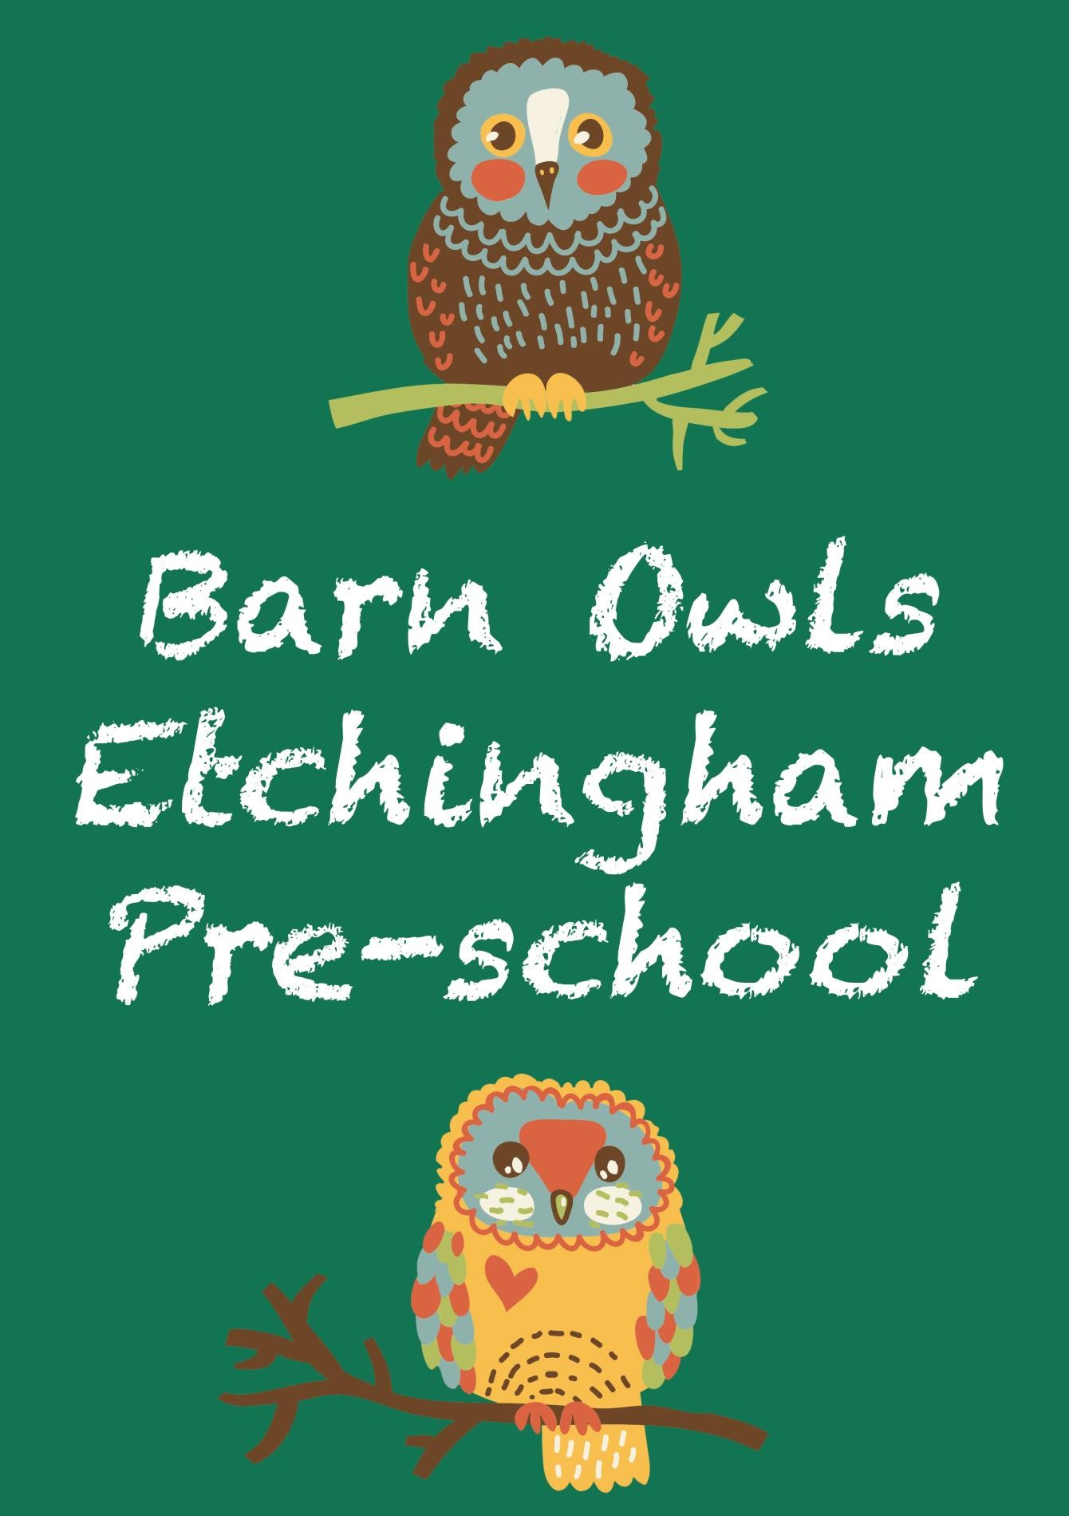

# Introduction

Barn Owls Pre-School (previously Etchingham Under Fives) is a popular and established pre-school, serving its local community and neighbouring villages. We cater for pre-school age children between 2 and 5. We are an inclusive setting and aim to meet the individual needs of all the children. We are a registered charity and are run by a Management Trust.

Our aim is to ensure that all children in our care have a positive introductory experience to their education. We work hard to support your child's emotional well-being so that she/he may develop a positive self-esteem and self-image. Our main focus is learning through play and to help children to form positive relationships with others. We pride ourselves on offering a safe, stimulating and caring environment with appropriately trained and knowledgeable staff. We encourage the involvement of all the families and carers that are connected with our setting so that, together, we can support your child with his or her individual needs.

The children are able to move freely between the indoor and outdoor environments where we have a safe and fully enclosed play area.

# Our Aims

Every child deserves the best possible start in life and support to fulfil their potential. A child’s experience in the early years has a major impact on their future life chances. A secure, safe and happy childhood is important and provides the foundation for children to make the most of their abilities and talents as they grow up.

Our aim at Barn Owls Pre-School is to enhance the development and education of children from age two through to the start of Reception. As we are registered by Ofsted we follow the Statutory Framework for the Early Years Foundation Stage, in a setting that encourages parental involvement.

To achieve this we:

 Provide a safe, happy, caring and stimulating environment in which the children can develop their skills through a balance of adult-guided and child-initiated play based activities.

 Fun and friendship with other children and adults, as well as opportunities for you and your family to be directly involved in the activities of the pre-school and in your child’s progress.

 Ensure that each child is treated as an individual, without prejudice or discrimination, and help them develop respect for others and their surrounding environment.

 Develop the confidence, sense of achievement, self-esteem and independence of the children through the experiences offered.

**Where are we?**

We operate from our own building at Parsonage Croft, Burwash Road, Etchingham TN19 7BY, alongside Etchingham Primary School.

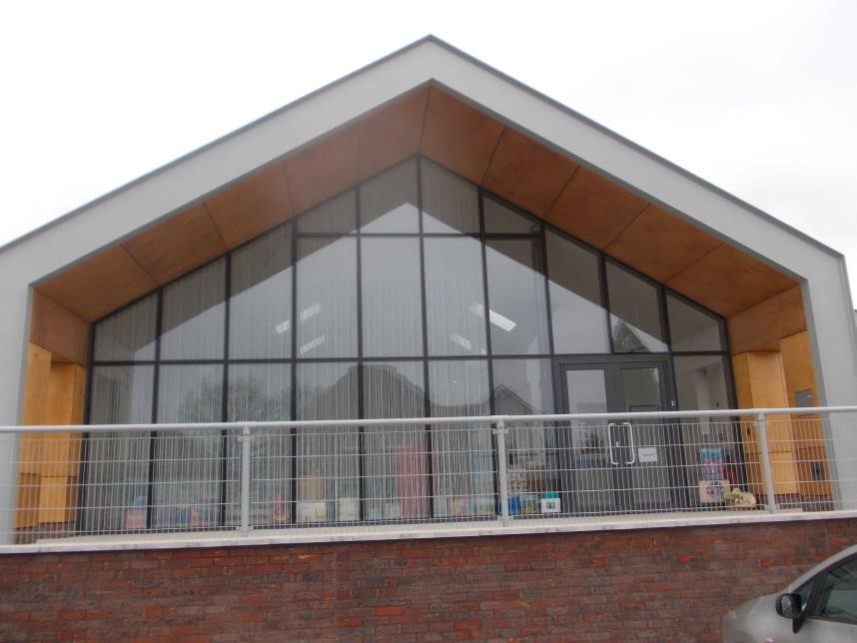

# Early Years Education Entitlement

Children are eligible to receive Early Years Education Entitlement (EYEE) funding the term after their 3rd birthday. This entitles each child to up to fifteen hours of childcare per week.

Barn Owls also offers 30 hours (extended) entitlement for qualifying parents of 3 and 4 year olds and up to 15 hours free childcare for qualifying parents of 2 year olds.

If you are unable to access funding or your child attends the setting for more than 15 hours a week and doesn’t qualify for 30 hours per week (extended entitlement), you will be charged at the rates below. At the beginning of term, parents are given a statement of the fees that are due for the term ahead. All fees are payable in advance. We also accept tax free childcare and childcare vouchers. At Barn Owls Pre-School the EYEE can be taken between 8.45am and 3.15pm Monday – Friday.

# Opening and Session Times and Fees

Morning sessions start at 9am until 12noon or 12.30pm (including lunchtime).

Afternoon sessions start at 12noon and finish at 3pm.

All day sessions start at 9am with pick up options at 2pm or 3pm. Early drop off (8.45am) and late pick up (3.15pm) options are also available.

|  |  |  |  |  |  |
| --- | --- | --- | --- | --- | --- |
|  | **Monday** | **Tuesday** | **Wednesday** | **Thursday** | **Friday** |
| **Pre-School** | 8.45-15.15 | 8.45-15.15 | 8.45-15.15 | 8.45-15.15 | 8.45-15.15 |

|  |  |  |
| --- | --- | --- |
|  | **Children 2-3 years** | **Children over 3**  (term after 3rd birthday) |
| **Cost Per Hour** | £6.80 | £6.30 |

.

# Early Years Foundation Stage

Barn Owls Pre-School follows the statutory framework for the Early Years Foundation Stage, ensuring that the setting complies with Learning and Development requirements and Welfare requirements. This approach ensures that we meet our aim for every child to grow up safe, healthy, enjoying and achieving.

Barn Owls Pre-School is registered with Ofsted. All our policies are available for viewing.

## Making it personal

Barn Owls Pre-School operate a key person system which helps with the transition period between the home and group environment for both you and your child. The key person will visit your child at home prior to joining and support your child throughout their time at Barn Owls Pre-School. They will share your child’s achievements with you and the next steps in their learning and development.

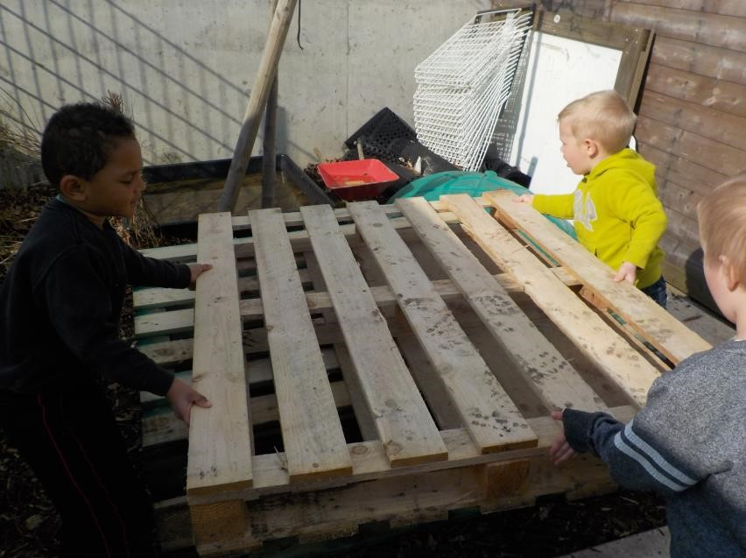

*Teamwork!*

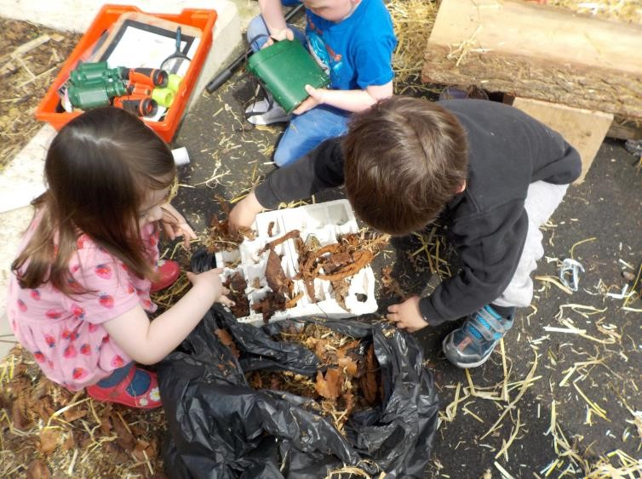

Exploring with friends

**And moving on...**

We have close links with Etchingham and Burwash Primary schools. At transition times the children are supported by visits to these schools and we in turn are visited by the Reception Class Teachers. Your child may also have the opportunity to join in with celebrations such as Harvest Festival, Christmas, Easter and Summer Fayres. Because we are based at Etchingham Primary School, the children are given plenty of opportunities to become familiar with the reception class, school hall and playground.

**What do I need to do next?**

To secure your place, please complete and return the enclosed Registration Form. We welcome visits at any time – please ring or email to arrange this. .

If you need any more information please telephone the pre-school on 01580 819218 (option 5) or email: helen@etchinghambarnowls.co.uk.

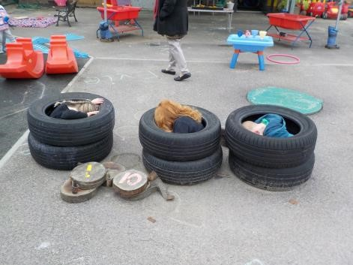

Anyone for hide and seek?

# Term Dates 2023-2024

|  |  |  |
| --- | --- | --- |
| Autumn | Spring | Summer |
| Term 1 | Term 3 | Term 5 |
| 4th Sept – 20th Oct 2023 | 4th Jan – 9th Feb 2024 | 15th April - 24th May 2024 |
| Term 2 | Term 4 | Term 6 |
| 30th Oct – 19th Dec 2023 | 19th Feb – 28th March 2024 | 3rd June – 12th July 2024 |
| Autumn Break  243rd – 27th October | Spring Break  12th – 16th Feb | Summer Break  27th May–31stMay |

**OUR DAILY ROUTINE**

|  |  |  |
| --- | --- | --- |
| Time | Activity | Links to EYFS |
| 9.00am (8.45am by prior arrangement). | Arrival  Self-Registration  Good Morning  Physically Active | PSED/CL/UW |
| 9.30am | Snack Bar – 10.35 finish  Continuous Provision  Indoor/Outdoor | All areas |
| 10.45am | Inside/OutsideTidy up | PSED/CL//PD |
| 10.50am | Letters and Sounds/Music/Numeracy | PSED/CL/UW/Maths/EAD/Lit |
| 11.05am | Continuous Provision - Outside | All areas |
| 11.40 am | Story followed by singing | PSED/CL/Lit |
| 12noon | Lunch, morning session finishes. | All areas |
| 12.40pm | Good Afternoon  Physically Active | PSED/CL/UW |
| 12.55pm. | Continuous Provision Inside/Outside | All areas |
| 2.00pm,3.00pm, 3.15pm | Home Time/Story/Games | All areas |

**NB Timings are flexible to meet the needs of the children and accommodate events within the preschool.**

**Routines will need to change during the year**

**Routines link to all the EYFS Principles**



|  |  |
| --- | --- |
| *Registration Form* | |
| Child's Name | Parent/Legal Guardian Name(s) |
| Date of Birth | Age Now |
| Child's Address      Postcode:  Tel. No.:  Email: | Parent's Address (if different)          Who child lives with: |
| We wish to join Barn Owls Pre-School   * As soon as possible * From * At the start of the term | |
| Days Preferred (circle as appropriate)    Monday am/pm Tuesday am/pm Wednesday am/pm Thursday am/pm Friday am/pm    Lunch Clubs  Monday Tuesday Wednesday Thursday Friday | |
| Signed: (Parent/Carer) | |